### **Workforce Administration Solution (Admin)**

The Workforce Administration Solution is a comprehensive software platform designed to automate and manage the processes related to employee project assignments and asset management within an organization. By centralizing employee data, this solution enhances efficiency in tracking employee performance, the number of projects an employee is involved in, and the assets assigned to them. It streamlines administrative tasks, enabling better decision-making through real-time insights and collaboration.

This platform is built on the Salesforce ecosystem, offering robust features such as data modeling, application development, and user interface customization to suit organizational needs. The integration of bulk data import capabilities simplifies onboarding and data management processes, while advanced security features in Salesforce ensure the protection of sensitive information. Group collaboration tools foster teamwork, and the use of reports and dashboards provides actionable insights into project performance and resource allocation.

**Creating a Salesforce Developer Edition Org**

Salesforce Developer Edition is a free, fully-featured version of Salesforce, allowing developers to experiment, innovate, and build custom solutions in a controlled environment. As a Salesforce Administrator for TheSmartBridge, having a Developer Edition org is crucial for implementing the projects and features required by the CEO. This environment provides access to Salesforce's powerful tools and APIs for prototyping, testing, and refining custom applications tailored to business needs.

Before creating the Salesforce Developer Edition account, it is important to understand the different Salesforce Editions available, as each is designed to meet specific business requirements.

### Types of Salesforce Editions:

1. **Essentials**: Designed for small businesses, it provides basic CRM tools to boost sales and service productivity, with a setup assistant for easy customization
2. **Professional**: Suitable for small to midsize businesses, it offers full CRM functionality, with customization, integration, and administration tools to facilitate business growth.
3. **Enterprise**: Aimed at large and complex businesses, it provides advanced customization, administration tools, and API access for integrations and large-scale deployments.
4. **Unlimited**: Extends the functionality of Enterprise Edition with additional features like Premier Support, increased storage, unlimited custom apps, and full mobile access.
5. **Developer**: Focused on developers, it provides access to the Lightning Platform, APIs, and tools for building custom applications and integrations. It includes many features of the Enterprise Edition, allowing developers to explore the platform’s full potential.

 Workforce Administration Solution (Admin)

* + Use Case
  + Salesforce
    - Use Case
    - Activity 1: Creating Developer Account
    - Activity 2: Account Activation
  + Object
    - Use Case
    - Activity 1: Create Employee Object
    - Activity 2: Create Project Object
    - Activity 3: Create 3 more objects with label names as ProjectTask, Asset, Asset Service.
  + Tabs
  + The Lightning App:
  + Fields & Relationships
  + Setting OWD
  + User Adoption
  + Import Data
  + Profiles
  + Role
  + Users
  + Page layouts
  + Chatter Group
  + Record Types
  + Permission sets
  + Reports
  + Dashboards

**Creating an object**

In Salesforce organization is essential for efficient data management and process automation. By defining custom objects, businesses can structure and store data specific to their needs, enabling streamlined workflows, personalized reporting, and enhanced user experiences. Objects serve as the foundation for organizing and leveraging critical information within Salesforce. As an Admin for TheSmartBridge, It’s your responsibility to store the data as per the organization needs.

To Navigate to Setup page:

Click on gear icon ? click setup.

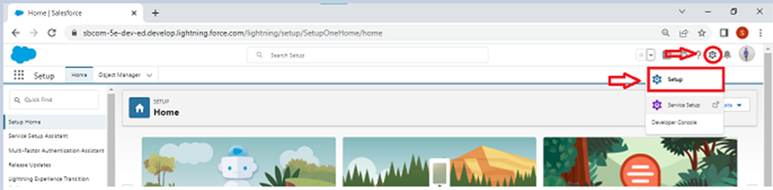

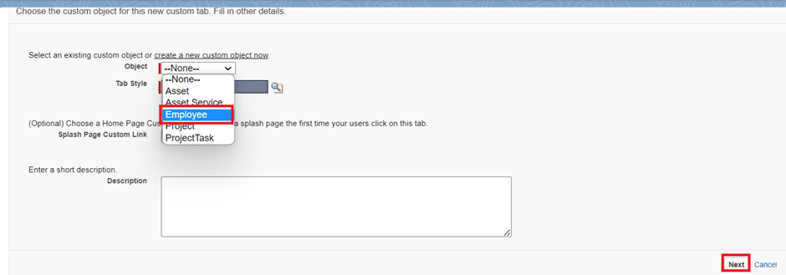

Creating Objects and storing TheSmartBridge organization’s data is the very first step in the requirements they want. Now to access the stored data by an employee from the organization Admin needs to create Tabs. By designing a dedicated Tab, businesses can improve user experience, simplify navigation, and provide quick access to critical information, enhancing productivity and ensuring efficient utilization of Salesforce's capabilities.

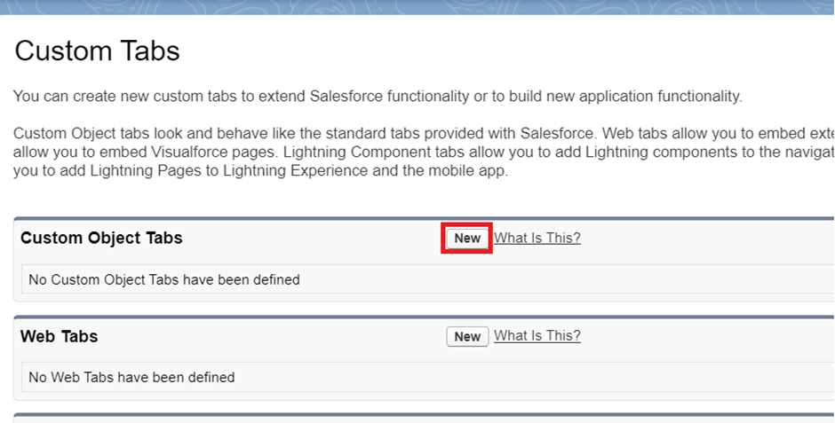

### **Activity 1: Create a Lightning App**

To create a lightning app page:

1. Go to setup page --> search “app manager” in quick find --> select “app manager” --> click on New lightning App.

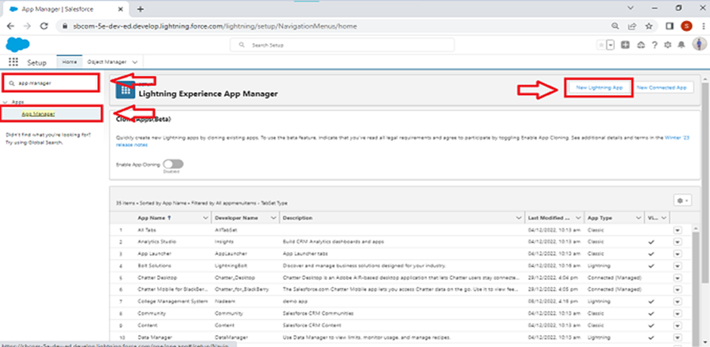

2. Fill the app name in app details and branding as follow  
App Name : Workforce Administrator Solution  
Developer Name : this will auto populated  
Description : Give a meaningful description  
Image : optional (if you want to give any image you can otherwise not mandatory)  
Primary color hex value : keep this default

3. Then click Next  --> (App option page) keep it as default --> Next --> (Utility Items) keep it as default --> Next.

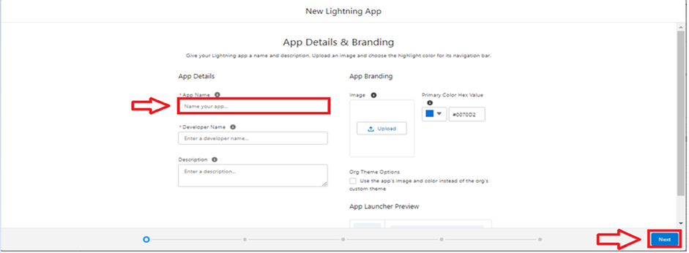

4. To Add Navigation Items:

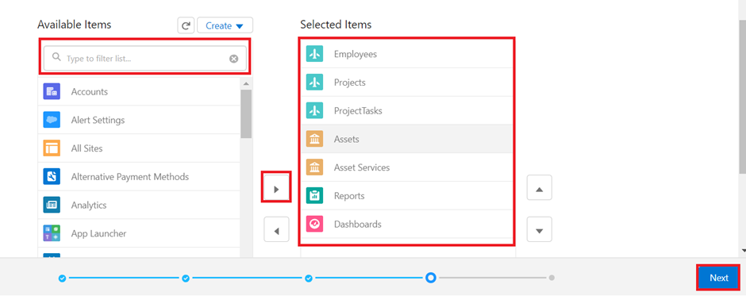  
Search the items in the search bar(Employees, Projects, ProjectTask, Assets, Asset Services, Reports, Dashboard) from the search bar and move it using the arrow button --> Next.

Note: select asset the custom object which we have created in the previous activity.

5. To Add User Profiles:

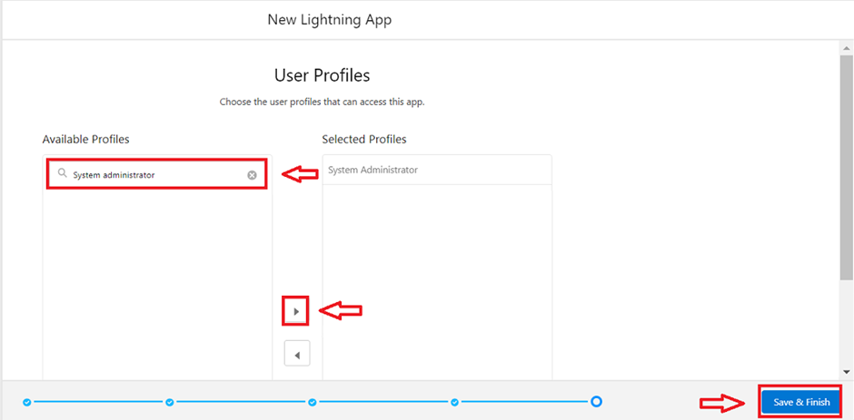

Search profiles (System administrator) in the search bar --> click on the arrow button --> save & finish.

**Fields & Relationships in Salesforce**

Salesforce operates as a powerful Customer Relationship Management (CRM) platform, and at its core, data is stored in objects. Each object contains records, and these records are composed of fields. Fields are the data containers in Salesforce, analogous to columns in a relational database. They store valuable information that a company needs to operate, track, and analyze. Salesforce categorizes fields into two main types: Standard Fields and Custom Fields.

### Standard Fields:

**Standard Fields** are the predefined fields in Salesforce, built into the platform by default. These fields perform essential tasks and come with every object created in Salesforce. Standard Fields serve common purposes and are widely used across different objects for storing basic and necessary information.

Some key Standard Fields include

* **Created By**: This field captures the user who initially created the record, including the date and time.
* **Owner**: Every record in Salesforce has an associated owner. This field identifies the user or team responsible for the record.
* **Last Modified**: This field logs the last user who modified the record and the corresponding timestamp.
* **Field Created During Object Creation**: Salesforce automatically generates fields when new objects are created, providing essential properties to help manage the data structure.

The important thing about Standard Fields is that they are non-editable in terms of functionality. You cannot delete them or alter their core purpose unless they are non-required fields. Salesforce safeguards the platform's integrity by ensuring that essential fields critical to record management and user activity tracking remain untouched.

### Custom Fields:

While Standard Fields are predefined and fixed, **Custom Fields** offer users the flexibility to extend Salesforce according to specific business needs. Companies can create and modify Custom Fields to capture additional information unique to their processes. Custom Fields are optional, meaning users have full control over.

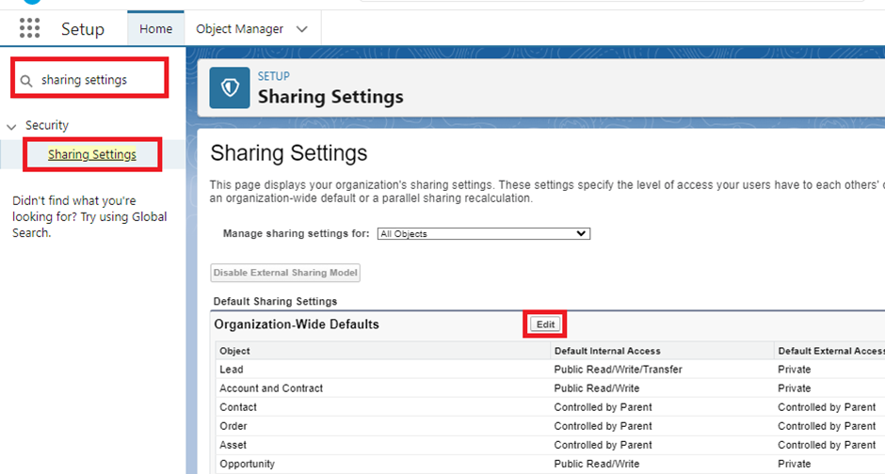

Organizations can add Custom Fields to track any form of data that is relevant to their workflow. For example, if a company wants to track a client’s preferred communication method (email, phone, etc.), it can easily create a custom field for that purpose. Furthermore, users can choose from a variety of data types when creating Custom Fields, such as text, date, picklist, formula, and lookup, to meet specific requirements.

**Setting OWD**

Organization-Wide Defaults, or OWDs, are the pattern security rules that you can follow for your Salesforce instance. Organization Wide Defaults are utilized to confine who can access what information in your CRM. You can award access through different methods that we will discuss later (sharing principles, Role Hierarchy, Sales Teams, and Account groups, manual sharing, and so forth).

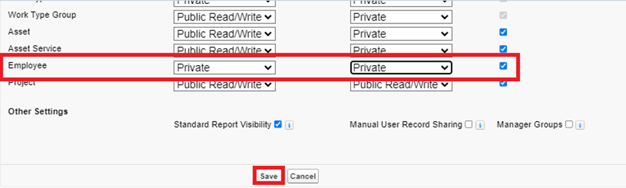

Primarily, there are four levels of access that can be set in Salesforce OWD and they are-

1. Public Read/Write/Transfer

2. Public Read/Write

3. Public Read/Only

4. Private

### **User Adoption**

## As a new Administrator, you perform user management tasks like creating and editing users, resetting passwords, granting permissions, configuring data access, and much more. In this unit, you will learn about users and how you add users to your Salesforce org.

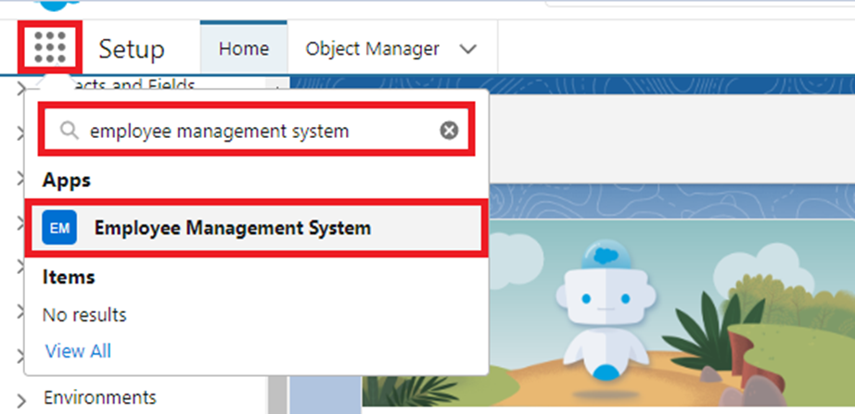

To view and manage employee information within Salesforce using the Employee Management System, follow these steps:

1. **Open App Launcher**: On the left side of the Salesforce interface, click on the App Launcher (represented by a grid icon). This will display a list of available applications in your Salesforce environment.
2. **Search for Employee Management System**: In the search bar at the top of the App Launcher, type "Employee Management System" to quickly locate the application.
3. **Open Employee Management System**: Click on the "Employee Management System" from the search results to access the application.
4. **Navigate to the Employee Tab**: Once inside the Employee Management System, locate the "Employee" tab on the top navigation bar. Click on it to view all employee records stored in the system.
5. **Select an Employee Record**: From the list of employee records displayed, click on the name of any employee. This will take you to the detailed view of that specific employee’s record.
6. **View Employee Details**: On the employee's record page, you can see various details such as personal information, contact information, assigned projects, performance data, and other relevant fields that have been configured in your system.

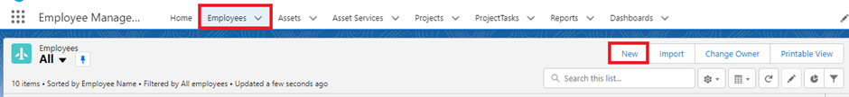

### **Profiles**

A profile is a group/collection of settings and permissions that define what a user can do in salesforce. Profile controls “Object permissions, Field permissions, User permissions, Tab settings, App settings, Apex class access, Visualforce page access, Page layouts, Record Types, Login hours & Login IP ranges. You can define profiles by the user's job function. For example System Administrator, Developer, Sales Representative.

## Types of profiles in salesforce

1. Standard profiles:

By default salesforce provides below standard profiles.

1. Contract Manager

2. Read Only

3. Marketing User

4. Solutions Manager

5. Standard User

6. System Administrator.

We cannot deleted standard ones

Each of these standard ones includes a default set of permissions for all of the standard objects available on the platform.

2. Custom Profiles:

Custom ones defined by us.

They can be deleted if there are no users assigned with that particular one.

### **Role**

A role in Salesforce defines a user's visibility access at the record level. Roles may be used to specify the types of access that people in your Salesforce organization can have to data. Simply put, it describes what a user could see within the Salesforce organization.

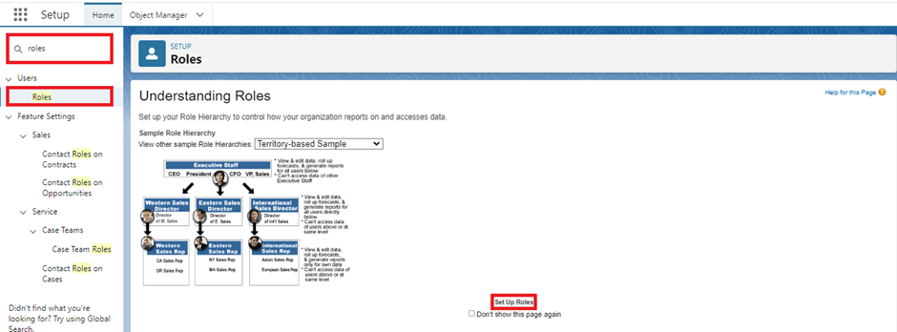

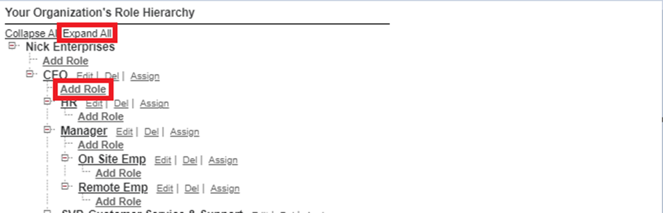

### **Users**

A user is anyone who logs in to Salesforce. Users are employees at your company, such as sales reps, managers, and IT specialists, who need access to the company's records. Every user in Salesforce has a user account. The user account identifies the user, and the user account settings determine what features and records the user can access.  
  
Every user in Salesforce has a user account. The user account identifies the user, and the user account settings determine what features and records the user can access. Each user account contains at least the following:

1. Username

2. Email Address

3. User's First Name (optional)

4. User's Last Name

5. Alias

6. Nickname

7. License

8. Profile

9. Role (optional)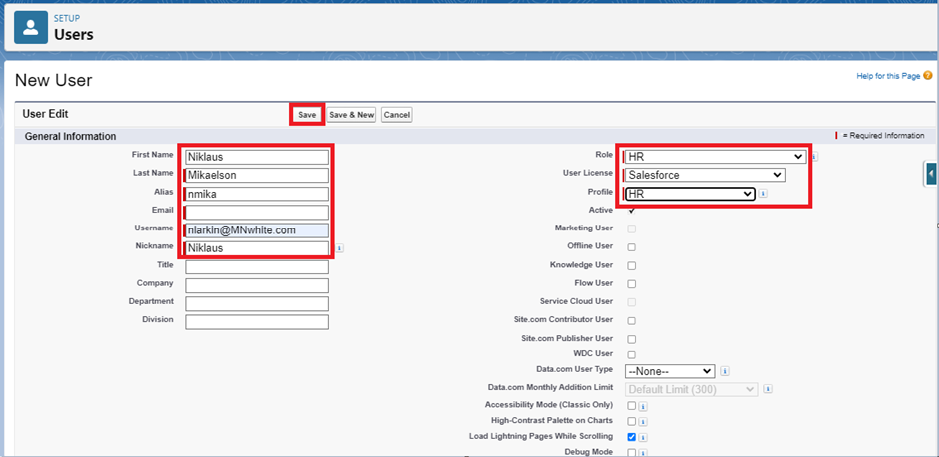

### **Page layouts**

Page Layout in Salesforce allows us to customize the design and organize detail and edit pages of records in Salesforce. Page layouts can be used to control the appearance of fields, related lists, and custom links on standard and custom objects' detail and edit pages.

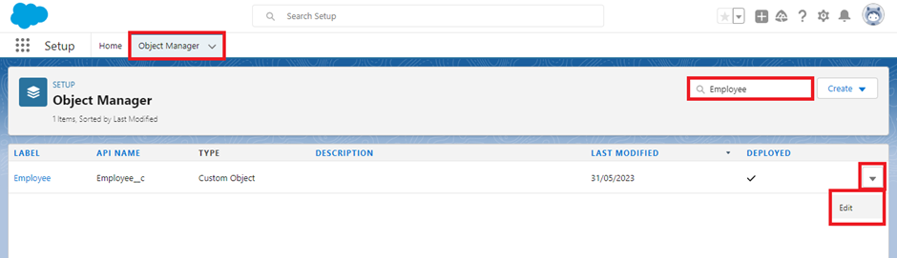

### **Permission sets**

A permission set is a collection of settings and permissions that give users access to various tools and functions. Permission sets extend users' functional access without changing their profiles. Users can have only one profile but, depending on the Salesforce edition, they can have multiple permission sets.

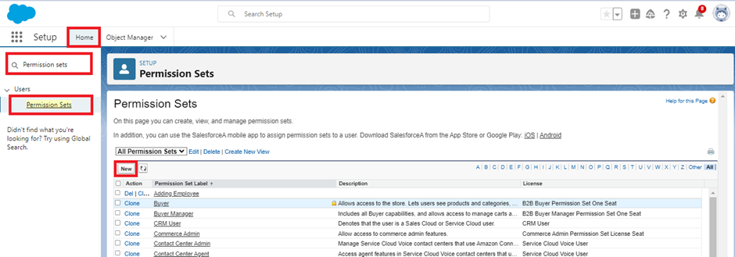

Every day is a war for Admin with some unique challenges. A new challenge awaits as you enter the office. After you arrive in office you came to know that the manger is on leave and there’s a lot work pending at his desk generally there are numbers of employee records that the manager have to enter in the salesforce org and no other person have the permission to create those records except him and your CEO wants it to be done by the end of the day, as it’s not possible to create the same profile and assigned it to some other person in the org. So using your admin knowledge you came up with the idea to create a permission set and assign it to someone who doesn’t have the access to do that job.

**Reports**

Reports give you access to your Salesforce data. You can examine your Salesforce data in almost infinite combinations, display it in easy-to-understand formats, and share the resulting insights with others. Before building, reading, and sharing reports, review these reporting basics.

Types of Reports in Salesforce

1.     Tabular

2.     Summary

3.     Matrix

4.     Joined Reports

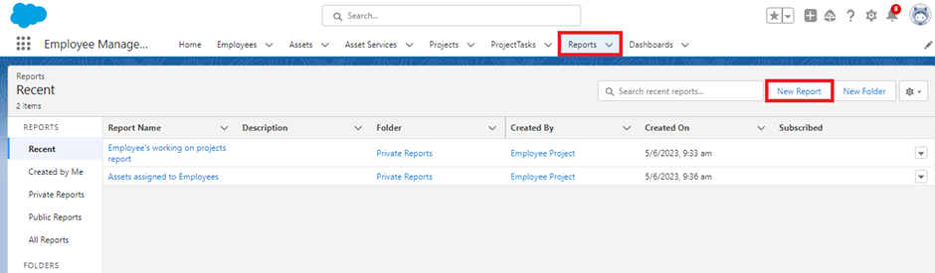

### **Dashboards**

Dashboards help you visually understand changing business conditions so you can make decisions based on the real-time data you’ve gathered with reports. Use dashboards to help users identify trends, sort out quantities, and measure the impact of their activities. Before building, reading, and sharing dashboards, review these dashboard basics.

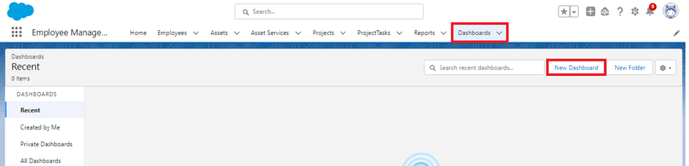

As an Admin for the organization you keep pushing yourself to reach out the business requirements to take the organization to peak heights and all your superiors are very much impressed with your efforts and work dedication. In addition with reports you make an ease for the CEO in viewing the reports with data visualization. So he doesn't have to search for the data he wants during the meetings.